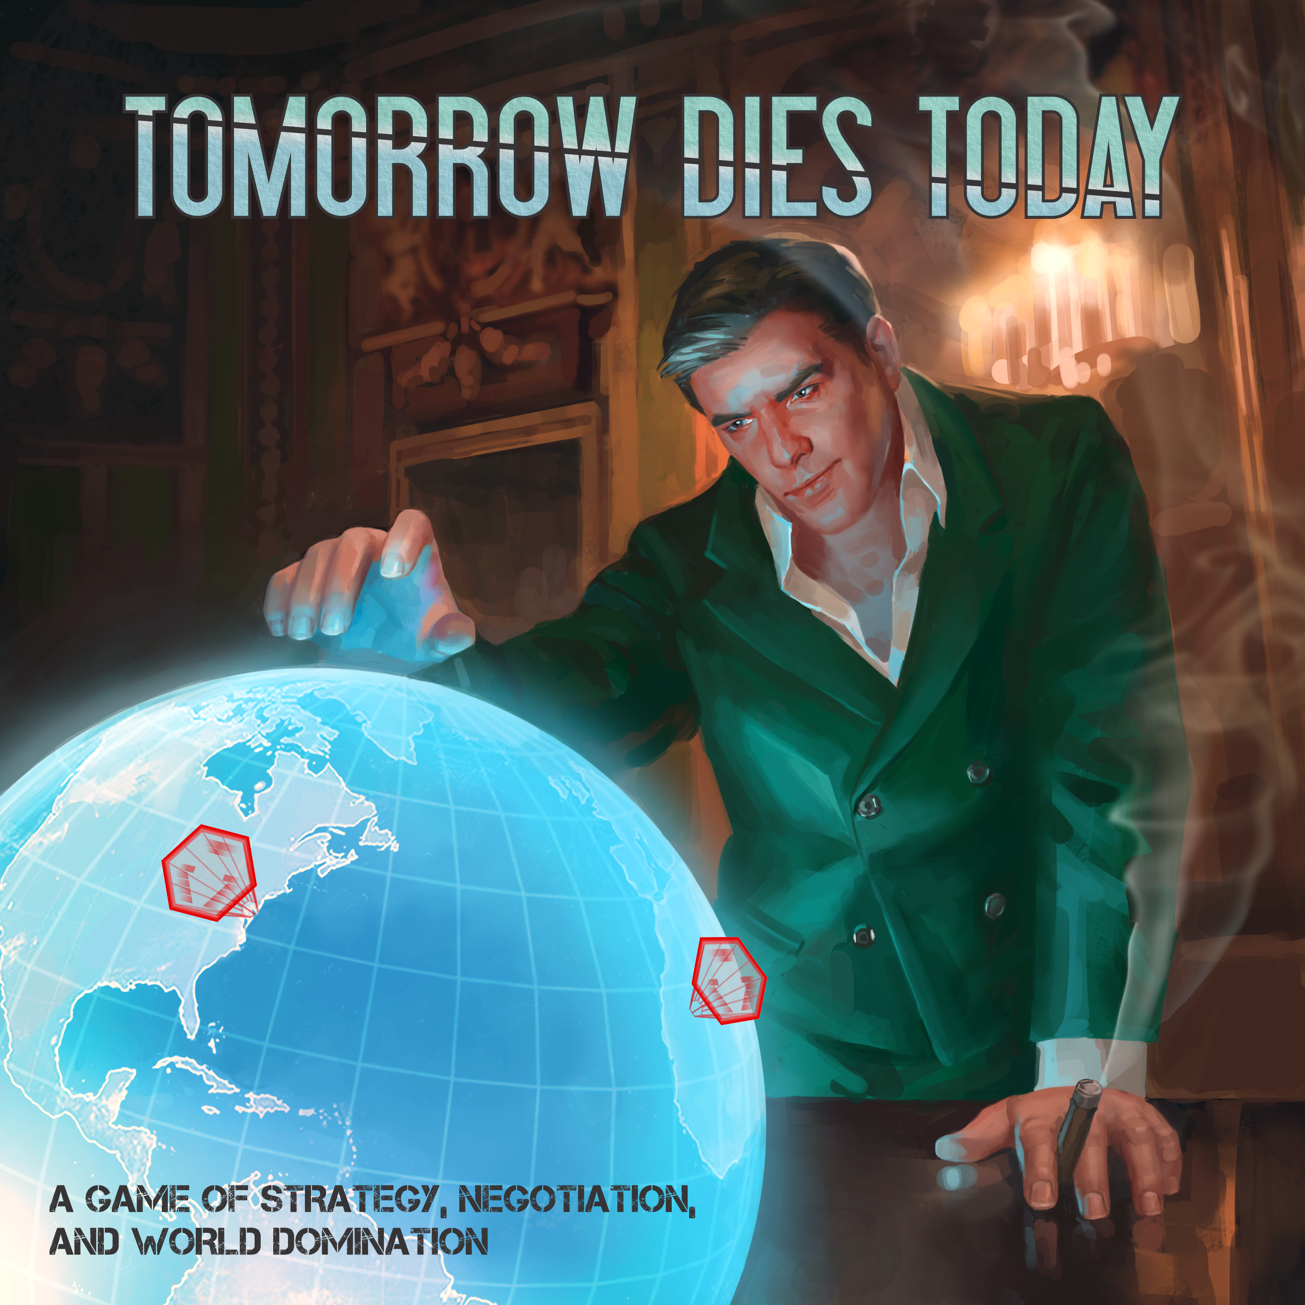
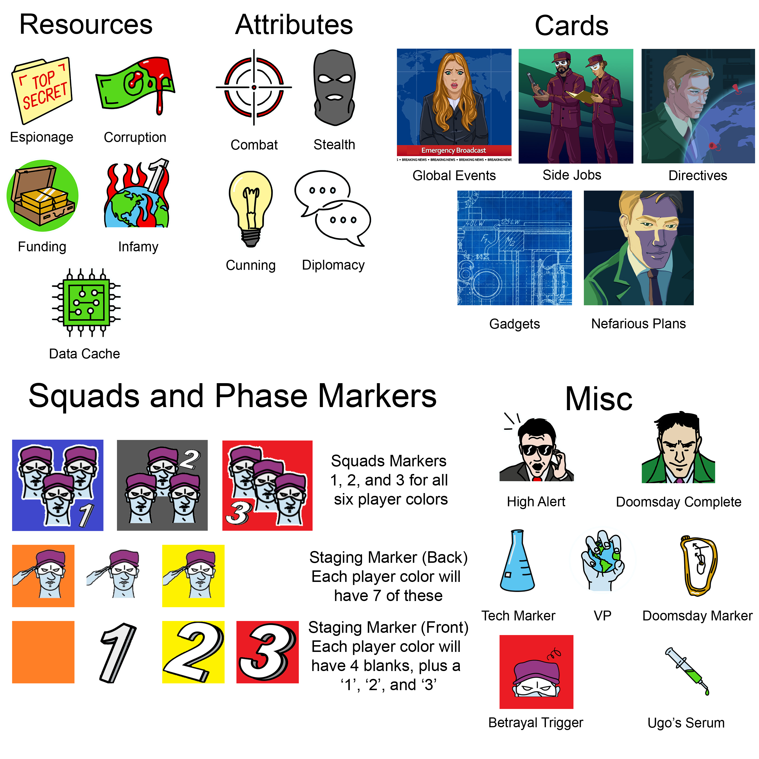
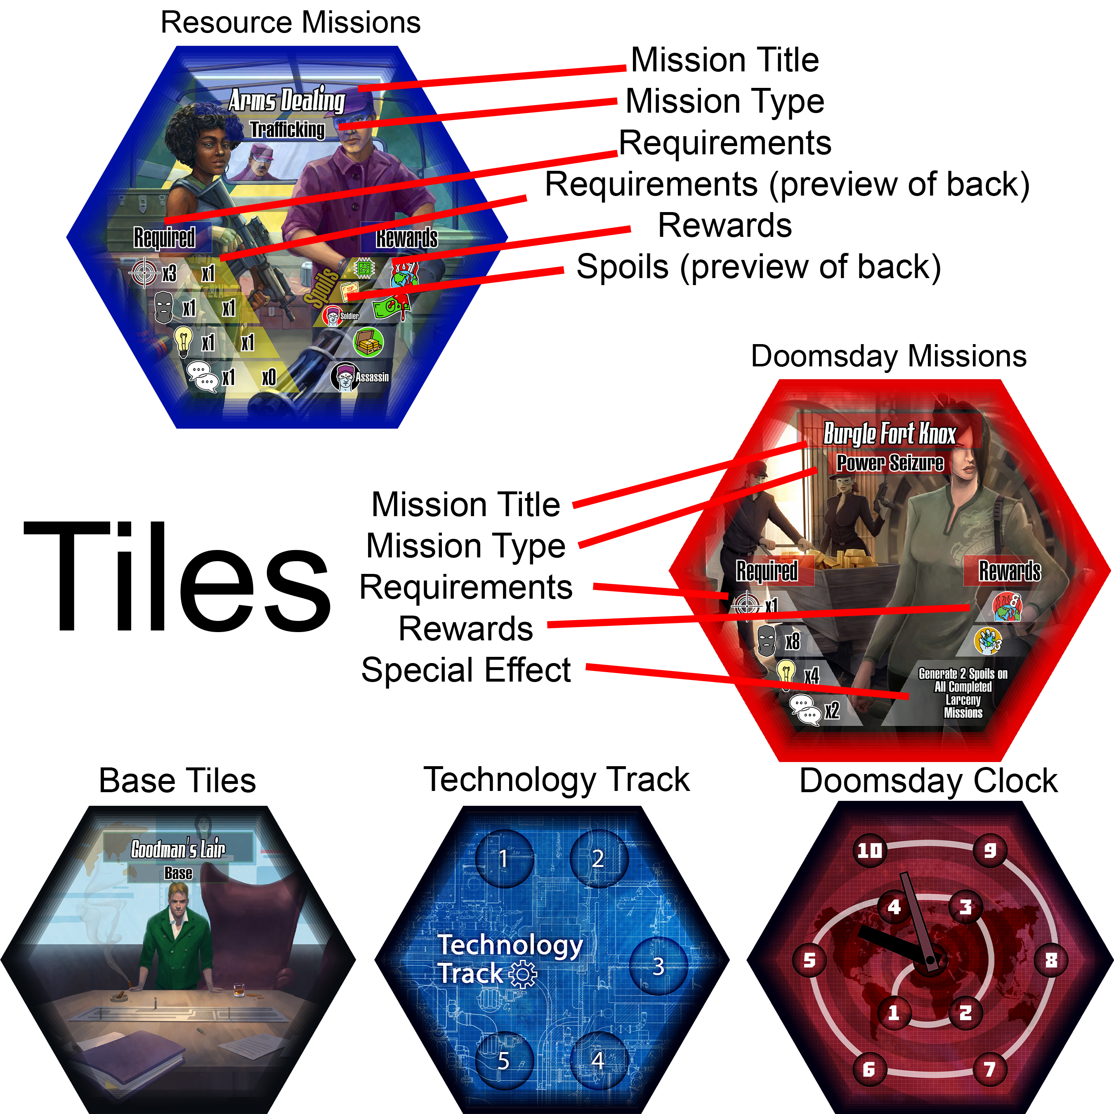
Setting and Goal of the Game

It’s time to let your inner villain out and take over the world!

‘Tomorrow Dies Today’ is a game of Supervillains and world domination. There are three game modes, with slight rules variations for each, but most of the mechanisms stay the same.

Your first step will be to choose between Cutthroat, Syndicate, and Mayhem game play.

Cutthroat | Syndicate | Mayhem
Cooperative & Competitive  (4-7 Players) | Solo/Cooperative  (1-6 Players) | Team vs. Team (vs. Team)  (2-6 Players)
3-5 Hours | 2-3 Hours | 2-3 Hours
While the rest of the world views General Goodman as a Supervillain, he sees himself as the leader to usher in a new golden age. Goodman has recruited a cadre of henchmen to help pull off his Doomsday Plan, which will in turn destabilize the world enough for him to seize control.  One player will represent Goodman, using guile, negotiation, and threats to guide his Henchmen to carry out his plan.  The rest of the players will build Squads, commit Villainy, and attempt to win by earning the most VP (Villain Prestige)… or decide to betray the organization and win by tearing it down. | All players will represent Named Henchmen.  Players must work cooperatively against the Doomsday Clock and world organizations to complete the Doomsday Plan. Global Events will periodically cause obstacles which players will have to resolve or navigate around. | General Goodman is taking over the world, but has room in his organization for the truly ambitious villains of the world.  Teams compete head to head over six rounds for the most VP, the winners gaining the prize of membership to Goodman’s new world order.
Shorthand Terms for These Instructions

RM – Resource Mission(s)
DM – Doomsday Mission(s)
BT – Base Tile(s)
NH – Named Henchmen
FH – Faceless Henchmen
GG – General Goodman
TL – Team Leader

Setup

- The main playing area is called the War Map
- Place Goodman’s Lair and the two Agent Headquarters (Interpol and CIA) apart from each other on the War Map
- Place a High Alert token on the Interpol HQ
- Designate an area for R&D (Research and Development). Draw three Gadget Cards and place them face up in R&D.
- Designate an area for Directives. Draw three Directives and place them face up in this section
- Designate an out of game area called the World
- The five types of Resources (Infamy, Corruption, Espionage, Funding, and Data Cache) and six types of Faceless Henchmen (Soldier, Assassin, Thief, Hacker, Scientist, Fixer) are placed in the World
- Determine who picks characters first via a die roll, or the person with the best evil laugh.

Pick Characters

Characters ‘In Play’ – Characters are considered ‘in play’ if they have a miniature on the War Map/in a Squad.

Cutthroat – 4-7 Players

General Goodman (Required) is a tough role that involves management of resources, leadership of the team, and balancing of potential betrayals. Goodman is also a mentor, picking out players falling behind or less familiar with the game and working with them to help find their feet. This is mutually beneficial, as Goodman succeeds when he has a good team. Goodman does not have a miniature on the board and cannot create Squads. His power lies solely with his ability to manage and influence his team.  Goodman achieves victory by completing his Doomsday Plan before the Doomsday Clock reaches 0 | The rest of the players will pick Named Henchman. Each has their own theme, Attributes, Special Abilities, and Betrayal Triggers which offer a unique global domination experience.  A Named Henchman can achieve victory by either having the most VP when Goodman completes his Doomsday Plan, or by Betraying the organization and running the Doomsday Clock down to 0.

Syndicate – 1-6 Players

Characters | Building the Base | Communal Vault
Each player chooses a Named Henchmen. For added difficulty, players may choose to represent more than one. | If there are less than six Named Henchmen in play, the team picks other Named Henchmen to fill out the proverbial roster. See the Plotting action to learn how to recruit these characters in game | Designate an area as a Communal Vault. This Vault can be deposited to during ‘Tithe to Goodman’, and withdrawn during ‘Requisition Resources’. Any effects that target a Henchman’s Vault do not affect the Communal Vault.

Mayhem – 2-6 Players (2-3 Teams)

Step 1 | Step 2 | Notes on Teams | Betrayal Triggers
Remove Goodman’s Lair | Teams alternate picking an equal number of Named Henchmen, with no more than six in play | Players may represent multiple Named Henchmen, with each considered a ‘player’ for the purposes of passing the Team Leader and Turn Orders | Betrayal Triggers represent disgruntled feelings, meaning teams still lose one VP for each Betrayal Trigger they have active at the end of the game

Team Leader

In Cutthroat, Goodman picks the first team leader. Otherwise, the person who has most recently committed a crime is the Team Leader… or you could just roll a die if you lead boring, law abiding lives. | The Team Leader receives any Rewards/Effects that normally would go to Goodman. Effects that give you the Team Leader token still do. If you gain the Team Leader Token while you already have it, you keep it for an additional round.

Henchmen Base Tiles

Place miniatures for Named Henchman in play on their Base Tile.

Place Base Tiles around GG’s Lair. Place random Base Tiles in the empty sections | Place all six chosen Henchmen tiles around GG’s Lair | Teams place their BT’s around the War Map after it is built (see page XX)

Henchmen Starting Resources and Objectives

 | Cutthroat | Syndicate | Mayhem
Faceless Henchmen | See ‘General Goodman’s Starting Assets’ below | The team gets 6 - Named Henchmen In Play | Team of one: 4 Henchmen  Team of two: 3 Henchmen  Team of three: 2 Henchmen
Resources | See ‘GG’s Starting Assets’ below | None | Any one Resource to each NH
Doomsday Plan | Goodman secretly selects a Doomsday Plan | Draw one randomly and place it face down near the War Map | N/A
Nefarious Plans | Goodman draws one Nefarious Plan per Henchman  Goodman gives one to each player (Characters under ‘Restriction’ cannot be chosen) | No Nefarious Plans in Syndicate | Deal all Nefarious Plans evenly to each team (discard one in the event of three teams)  Each team picks one (it cannot have any of their characters under ‘Restriction’)
Side Jobs | - Each player draws the Side Job with their Henchman’s name below the title  - Players each draw four more Side Jobs  - Everyone reviews their five Side Jobs, keeps two, then returns the rest to the deck  - Shuffle the Side Jobs deck

General Goodman’s Starting Assets

General Goodman starts with Resources based on the number of Named Henchmen in play
# of Henchmen | Any Resources | Faceless Henchmen | VP
3 | 12 | 3 | 2
4 | 10 | 2 | 2
5 | 10 | 1 | 3
6 | 8 | 0 | 3

Resource Missions and the Interpol Agent

6 Resource Missions will be placed around the Interpol HQ tile by players. Shuffle the 18 tiles and pass them out as follows:

Cutthroat

Players | Number of Tiles | Placement Order | Unused Tiles
4 | 4 per NH, 6 for GG | GG, TL, clockwise around the table, then GG and TL again | GG returns all of his unused RMs to the world.  Players tithe 1 RM to GG, returning the rest to the world
5 | 3 per NH, 6 to GG | GG, TL, clockwise around the table, then GG again
6 | 3 per Player | GG, TL, then clockwise around the table
7 | 3 per Henchman | TL, then clockwise around the table
Players may reveal their tiles, discuss options, and negotiate placements before placing tiles around Interpol HQ

Syndicate

Step 1 | Step 2 | Step 3 | Step 4 | Step 5
The team draws 9 Resource Mission tiles | Pick 6 tiles to place around Interpol HQ | Draw 3 more tiles | The 6 drawn tiles are placed in the Communal Vault | The last 6 tiles are removed to the World
The end result should be 6 tiles on the War Map, 6 in the Communal Vault, and 6 in the World.

Mayhem

Step 1 | Step 2 | Step 3
Split the 18 tiles between the teams | Teams negotiate, then alternate placing tiles around Interpol HQ (Starting with the TL) | Each team places half of the remaining tiles in their Vault, returning the rest to the World

The Interpol Agent starts on the Resource Mission that was placed on the War Map first.

Doomsday Missions and the CIA Agent

Place the CIA Agent on the CIA Headquarters tile. Six Doomsday Mission Tiles must be placed around the CIA Headquarters. Shuffle the Doomsday Mission Tiles and pass them out accordingly:

Cutthroat

Step 1 | Step 2 | Step 3 | Step 4 | Step 5
Pass out tiles (see table) | Players negotiate, then place one facedown in a pile in the order described below | Shuffle and place the six tiles around the CIA HQ | GG returns his unused tiles to the World, then places other players’ unused tiles in his Vault | Goodman returns Doomsday tiles in excess of 3 to the World

Players | Number of tiles | Pass Tiles Out in this Order
4 | 3 per player | GG, TL, clockwise around the table, then GG and TL again
5 | 2 per player, +1 for TL and GG | GG, TL, clockwise around the table, then GG again
6 | Two per player | GG, TL, then clockwise around the table
7 | Two per Henchman (Goodman doesn’t draw) | TL, then clockwise around the table

Syndicate

Step 1 | Step 2 | Step 3
Draw 6 at random (do not look at them) and place them facedown around the CIA HQ | Draw 3 at random and place them facedown in the World | Place the last 3 Doomsday Missions in the players’ Communal Vault

Mayhem

Step 1 | Step 2 | Step 3 | Step 4
Split the tiles equally between the teams | Teams negotiate, then equally contribute to a communal pile of 6 facedown tiles | Shuffle and place the facedown tiles around the CIA HQ | Each team keeps one of the remaining tiles in their Vault. The rest are placed facedown in the World

Doomsday Missions in the World remain facedown unless a special abilities/events/Gadget allows for a player to view them.

Betrayer’s Bolthole, Gadget Track, the Doomsday Clock, and Global Events

Place the following tiles between the indicated places on the War Map
Betrayer’s Bolthole | Technology Track | Doomsday Clock
Resource and Doomsday Missions | Base and Resource Missions | Base and Doomsday Missions

The Doomsday Marker starts at
Named Henchmen | Cutthroat | Syndicate | Mayhem
1 | N/A | 10 (Global Event) | N/A
2 | N/A | 9 | 6
3 | 10 | 8 (Global Event) | 6
4 | 9 | 8 (Global Event) | 6
5 | 8 | 7 | 6
6 | 7 | 6 (Global Event) | 6

A Global Event (Mandatory in Syndicate) is active at the start of the game if the Doomsday Clock starts on an even number.

Place tokens on your Betrayal Triggers that are currently active. Players lose one VP for each active trigger at the end of the game in Cutthroat and Mayhem, and cannot end the game if they have 3 or more triggers active in Syndicate.

The first betrayal trigger relates to the Team Leader and may be ignored in Mayhem/Syndicate.

Game Objective

Cutthroat

The Objective of the game depends on whether you are playing General Goodman or one of his Named Henchmen.
General Goodman | Named Henchmen
Goodman has a straightforward, but difficult task: Complete his Doomsday Plan and achieve total world domination! If he does so, he wins. However, Goodman has no pieces on the War Map. He must act through his Named Henchmen by negotiating, bribing, or threatening them into actions that will promote his agenda. He is incentivized to ensure a level playing field, and should watch for those falling too far behind, lest they be tempted to betray his organization. Goodman is also in charge of managing the Round, timer, and ensuring Actions are taken in order. | Named Henchmen lack the drive and vision of General Goodman, and instead seek to be the most villainous villain to ever villain. Doing so will secure them a place as a top Henchmen in Goodman’s new world order. They have two ways they may go about this:  - Loyal - If the Henchman remains loyal to the cause and Goodman achieves world domination, the Named Henchman who collected the most VP (Villain Prestige), minus their active Betrayal Triggers, is the victor. In the case of a tie, the Henchman with the most completed Objectives, not including completed Disloyal Side Jobs, wins. If still a tie, the Henchman with the most Resources plus Gadgets wins. If still a tie, the Henchman with the least Betrayal Triggers wins. If still a tie, ten paces at dawn with pistols should resolve the matter  - Betrayer - If the player becomes the Betrayer, they are now working contrary to the rest of the table and seek to foil Goodman’s plans. They must run the Doomsday Clock down to zero, thereby foiling the Supervillain’s plot and creating a power vacuum for their own nefarious vision
The game ends with Goodman and a Henchman achieving victory, or with GG failing and victory going to the Betrayer

Syndicate

General Goodman (not a playable character in this version) has assigned his top henchmen to carry out his will. They have a limited amount of time before the world’s forces find Goodman’s base and shut the operation down. They must carry out his Doomsday Plan before the Doomsday Clock hits zero, and must have no more than two active Betrayal Triggers each. If they do so successfully, the players win!

Mayhem

General Goodman is in the process of instituting a new world order. He has put the call out for insidious henchmen who want to join his organization. Ambitious villains have teamed up to make a name for themselves, looking to complete Goodman Directives and Doomsday Missions to ensure they catch the Supervillain’s eye. Once the Doomsday Clock reaches zero, Goodman has completed his plan and taken over the world. By achieving the most Villain Prestige, a team will earn the right to be recruited into Goodman’s new world order.

As a note for Mayhem, if a rule ever states to ‘go around the table’, start with the Team Leader (unless otherwise directed), and alternate between players on each team.

Round, Stages, and Action Order

The Round encompasses all Stages and Actions from ‘Scheming’ to ‘The World Reacts’.

The Round is divided into three Stages: Scheming, Villainy, and Monologuing. These Stages serve as organizational buckets for the Actions taken within them.

Within each Stage are Actions: Deploy, Complete Missions, Tithe to Goodman, etc. Each Action has specific guidelines on how players interact with each other, the War Map, and the World.
Each Round will have three Phases during Villainy. This represents the complex schemes and plans being executed on the War Map. The Villainy Stage will be repeated three times, once for each Phase, after which you move on to the Monologuing Stage.

It is recommended to set a timer for each Stage to keep people on task. Negotiations and planning can lead to circular discussions and paralysis by analysis. Having General Goodman/The Team Leader keep a timer will keep the game from going too long.

The Structure of a Round

Scheming (10 minutes)  Interpol/CIA Security Sweep  Coordination  - Requisitions Resources  - Plotting  - Build Gadgets  - Commit Forces  Place Staging Markers  Reveal Staging Markers  Remove Blank Staging Markers | Villainy (3 Phases – 1 minute per Phase per player)  Agents Investigate  Fund Deployment  Deploy  Generate or Collect Spoils  Complete Missions  Collect Mission Rewards  Remove Staging Marker  Next Phase | Monologuing (2 minutes per player)  Voluntary Recall  Tithe to Goodman  Complete Goodman Directives  Complete Side Jobs  Goodman’s Plotting Actions  The World Reacts

After all Actions in all three Stages take place, a new Round starts.

Taking Turns/Order of Operations

Actions are resolved by tile (unless explicitly stated otherwise) starting with the TL’s tile, then clockwise around the table.

During Mayhem, ‘going around the table’ must alternate between teams. The goal is to not allow the same team to resolve events or claim objectives one after another before another team gets an opportunity.

To expound more, resolving the order of an action/event should start at the Team Leader, followed by the person on the next team who will be the Team Leader, followed by the person who will get the token the following Round, etc.

Scheming

Recommended Time Limit

Negotiation and planning will take the most time in the game. Set a timer for 10 minutes for this Stage.

Interpol/CIA Security Sweep

During this Action, loitering Squads on Interpol/CIA HQ receive damage equal to the High Alert tokens present on the HQ.

Coordination

Players take turns taking one of each Coordination action. This continues until no one has actions to take. Individuals/teams may pass if they don’t have anything to do during their turn, but may take an action when it comes back around to them.

Requisition Resources

Cutthroat

GG may exchange one Infamy for any one Resource as many times as he has Infamy | GG retains Resources in his Vault and FH on his tile. During this Action he may move his FH to any NH’s Base Tile and/or Resources to their player's Vault(s) |  | If a tile was previously removed from the War Map and not replaced, GG may fill spaces with tiles from his Vault. There should never be more than six Resource and Doomsday Mission Tiles on the War Map |  |  | GG may spend one Infamy to reassign the TL
Syndicate

As above, though the Team Leader takes the role of Goodman, and must spend 3 Infamy per Resource
Mayhem

As in Cutthroat with the following modifications: |  | The Team Leader may Requisition Resources with 2 Infamy instead of 1, and may replace Mission Tiles on empty spaces |  | Non-Team Leaders may Requisition Resources at a 3:1 ratio | Any player may spend 1 VP to add a Faceless Henchman to their Base

Plotting

Unless explicitly stated in the ability, Henchmen take Espionage, Gadget, and Special Ability actions from their Base Tile during this Action. Their Plotting actions are limited to the number of Espionage Resources they have available.

If a tile is removed and not replaced, Henchmen/Squads on the tile are returned to their Base, High Alerts return to the World, Agents are moved forward a tile, and Agents moving onto the space in the future skip the empty tile and move to the next.

Target | Espionage Cost | Effect
Side Jobs | 1 | Draw three Side Jobs. Keep one, return the others to the top of the deck, and shuffle if desired
Gadget | 1 | Draw three Gadgets, place one in R&D, place the others on top of the deck. Shuffle if desired
Switch out a RM | 1 (+1 if Occupied and for each High Alert Token) | Move a Resource Mission from the War Map to Goodman’s Vault. You may replace with a tile from your Vault. Otherwise GG has the same opportunity. New Missions come into play Active.
Remove a RM to the World | 2 (+1 if Occupied, and for each High Alert Token) | Remove a Resource Mission tile from the War Map and place it in the World. You may replace it with one from your Vault. Otherwise GG may replace the tile with a RM from his Vault. The new mission comes into play Active. The space remains empty if the tile isn’t replaced.
Reveal a DM | 1 | Flip a DM from Active. Add one High Alert token to the CIA HQ if this is the first DM tile flipped.
Remove an Inactive/Active/Completed DM | 2/3/4 respectively (+1 if Occupied) | Remove a Doomsday Mission from the War Map and place it in the World. You may replace it with a DM from your Vault. Otherwise, GG may replace the tile with a DM from his Vault. Replaced tiles come into play Inactive. The space remains empty if the tile isn’t replaced.

Syndicate

If less than six Named Henchmen are in play, players may spend VP to hire a Named Henchman whose Base Tile is on the War Map. Place the hired Henchman’s miniature on the hiring player’s tile. They act as a Faceless Henchman for all mechanical purposes, with the exception that they may use its special abilities as if they were on their own tile.

The VP cost of bringing in a Henchman is as follows:
- (2 * Named Henchmen in play) VP if the Doomsday Plan has not been revealed
- (3 * Named Henchmen in play) VP if a Doomsday Plan has been revealed

Build Gadgets

Named Henchman on their Base Tile may purchase a Gadget from R&D and place it in their Vault. They must spend Data Cache equal to the current level of the Technology Track. Doing so raises the Technology Track by one (max of 5).

Alternatively, spend Corruption equal to the current Technology Track to raise or lower the Technology Track by one.

Commit Forces to Squads

Henchmen may be committed to Squads during Coordination. Henchmen outside of a Squad cannot Deploy on the War Map, and may only sit passively on a tile and defend against Conflicts initiated against them.
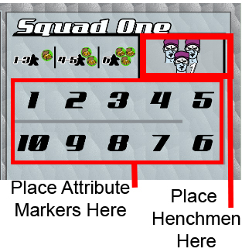
The rules of creating Squads are as follows:

- You may disband Squads on your Base Tile and return Henchmen to your Base
- You may create new Squads from Henchmen who are on your Base Tile
- Henchmen in a Squad should be moved to the Squad on the player’s character sheet. To avoid recalculating Attribute totals, you may put Attribute markers on the numbers to keep track of the Squad’s combined Attributes
- Move the appropriate Squad 1, 2, or 3 Marker to the player’s Base Tile
- Each player may have up to three Squads
- You cannot have a Squad with more than six Henchmen
- A Squad that has all of its Henchmen removed (damage, etc.) is disbanded
- Squads may be Deployed. Henchmen may not Deploy without a Squad

Place Staging Markers

Staging Markers determine where Squads can Deploy for each Phase.

Players place five Staging Markers on the War Map face down. Markers will be blank, or have an indicator for Phase 1, Phase 2, or Phase 3. Players may place multiple markers on one tile if they choose. Tiles with a number indicate the Phase a player will be attempting to Deploy during the Round.

Players may place Staging Markers one by one in a clockwise order, starting with the Team Leader, or all place together if they unanimously agree to. Players may not remove tiles once they are on the table.

Cutthroat | Syndicate | Mayhem
Betrayers must deploy to the base entrance before deploying to a tile in Goodman’s Base | Players only place three markers, and they do not have to be face down | Players may not place Staging Markers in another Team's base

Reveal Staging Markers

The facedown markers are revealed. Markers should remain untouched until the appropriate Phase unless a mechanic explicitly allows.
Remove Blank Markers

The blank markers have served their purpose as distraction tools. They are removed.

Villainy

Players go out into the field and perform deeds of villainy during this Stage. They will Deploy to tiles on the War Map, interact with Missions, Agents, other players, harvest resources, and complete Objectives before returning to Base to brag during Monologuing.

All Villainy Actions are repeated three times over the course of three Phases. This will give players opportunities to take three different sets of Villainy Actions on the War Map before proceeding to Monologuing.

Phases

Players Deploy Squads to the Staging Marker for Phase One, taking their Villainy actions and resolving Conflicts before doing the same for Phase Two, and finally Phase Three.

Phases are resolved in order, starting with the Team Leader’s tile and going clockwise around the table. While most players will Deploy in every Phase, not every Phase has to be participated in by every player.

Recommended Time Limit

It is recommended to set a timer for 1 minute per Phase per player for this Stage. Scheming takes a while, but comparing numbers and resolving actions should be relatively quick. If a Conflict occurs, allot an additional 2 minutes to resolve it.

Fund Deployment

Squads cost the following to Deploy
Units in Squad |  |  | 1-3 Henchmen | 4-5 Henchmen |  | 6 Henchmen
Cost |  |  | 1 Funding | 2 Funding |  | 3 Funding
From Base/Staying on the same tile (only discount one Squad) |  |  | 0 Funding | 1 Funding |  | 2 Funding
Funding Examples
Normal Funding | Base Discount | Squad Already on Tile |  |  | You Must Deploy if Able
3 Squads  2 Henchmen in each Squad  Deploying *from* three different Mission Tiles  Deploying *to* Murder Incorporated.  Cost: 3 Funding (1 for each Squad) | 3 Squads  2 Henchmen in each Squad  Any one (or all) Squads Deploying *From* a Base Tile  Deploying *to* Murder Incorporated.  Cost: 2 Funding (1 for each Squad, minus 1 discount) | 2 Squads  4 Henchmen in each Squad  Deploys Squad 1 *from* Arms Dealing  Deploys Squad 2 *from* Murder Incorporated  Deploys both Squads *to* Murder Incorporated  Total Cost: 3 Funding (2 for each Squad, minus 1 Discount of Squad 2 not having to move. Both Squads may act this Phase)  Alternate Cost: 2 Funding (2 for Squad 1, and 0 for Squad 2, though Squad 2 is Idle this Phase) |  |  | If you saw a big bad enemy Squad ready to Deploy to Murder Inc, you still have to Deploy there if you have a Squad you can afford to send. Your minions were given orders and funding in advance, and are eager to please. That said, you can send an expendable Squad to minimize your losses.  Don’t worry, no one will miss those henchmen anyway

Deployment encompasses the transport, lodging, equipment, and logistical coordination of Squads. A Deploy action and appropriate Funding are required to move Squads and/or take action on any Tile, else they don’t have the resources they need to execute your evil plans.

Multiple Squads may be Deployed *to* the Staging Marker for the current Phase, though they do not have to come *from* the same tile.

If any of a player's Squads are deploying from a Base Tile and/or remaining on a Mission Tile, the total cost for the Phase’s Deployment is one less Funding. Players do not get a discount per Squad, and can therefore only ever get a total discount of one per Deployment.

It’s easy to return home and/or wander the Base. Deploying back to Base, or from one Base Tile (or the Base Entrance) to another Base Tile, is free.

Players choose what Squad(s) will be Deploying and spend Funding based on the Squad size(s), applying discounts and penalties as appropriate.
If you do not have enough Funding to deploy any Squad, you spend nothing, the Deployment automatically fails, but you may participate in the next one.
Henchmen are desperate to please their evil overlords and follow orders. If the Player *does* have enough Funding to Deploy an available Squad during a Phase they have placed a Staging Marker, they must fund it and Deploy at least one Squad.

Travel Squads (aka, Supervillain Ridesharing)

If multiple Squads from one or more players are Deploying *from* the same tile, or *from* their Base, and all have the same destination, they may Travel together as one Squad (Squad limit of 6 still applies). These Supervillain ride shares combine for the trip, then split back into their normal Squads once they reach their destination, though the Temporary Travel Squad may be funded by any of the travelling players. Creative uses of this rule can lower the cost of deployment and/or allow Squads to tag along when their player had otherwise run out of Funding. Characters like Azura like picking up hitchhikers, and Axle benefits from giving others a Tune Up before bumming a ride.

Travel Squad Examples
Combining Special Abilities | Group Discount | Group Discount Part 2
Squad 1 – 2 Henchmen  Squad 2 – 4 Henchmen  Combined Travel Squad – 6 Henchmen  Funding Cost  Normal: 3 Funding  From Base: 2 Funding  From Base with Azura Flying: 1 Funding  From Base with Azura Flying with a Tune Up from Axle: 0 Funding | Squad 1 (Player 1) – 1 Henchman  Squad 1 (Player 2) – 1 Henchman  Squad 1 (Player 3) – 1 Henchman  Deploying *from* Arms Dealing  Deploying *to* Murder Inc  Funding Cost  Normal: 3 Funding  Together: 1 Funding | Squad 1 (Player 1) – 1 Henchman  Squad 1 (Player 2) – 1 Henchman  Squad 1 (Player 3) – 2 Henchmen  Deploying *from* Arms Dealing  Deploying *to* Murder Inc  Funding Cost  Normal: 3 Funding  Together: 2 Funding

Deploy

- Players move the Squad(s) they paid to Deploy to the Staging Marker for this Phase
- You may Deploy multiple Squads from different tiles to a single destination. The Staging Marker indicates the destination and Phase the Squad(s) may Deploy
- A Squad that hasn’t been Funded and Deployed will sit Idle. Idle Squads cannot initiate a Conflict, but will defend if attacked, and can use Corruption if an Agent shows up
- Whether a Squad is moving or staying on a Tile, they cannot take Actions unless they have been successfully Funded and Deployed to a tile with a Staging Marker for that Phase
- If a Squad is deploying to a tile which already contains a Squad belonging to that player, only the Squad(s) that are funded may take Action during the Phase. This means the player can choose not to fund a Squad already on a destination tile and have them sit Idle while the newly arrived Squad takes Actions
- Agents may be corrupted by Squads Deploying to their tile to avoid increased mission Requirements. Players must spent an amount of corruption equal to the High Alert Tokens on the tile + High Alert tokens on the Agent HQ

Player vs. Player Interactions and Conflicts

Two Players, One Tile - When two or more players are on a tile, they may act as following between any two Actions.

- Glare menacingly at one another from across the table
- Exchange Resources, Gadgets, Henchmen, or VP
- Initiate a Conflict (once per Phase)

Exchanges - Players on the same tile or base may exchange Resources, Gadgets, Henchmen, or even VP.

Conflict – Deployed Squads may attack other Squads on their tile. Conflicts may happen once per Phase (Villainy).

Henchmen attacked outside of Squads are all considered to be in a Squad together (6 per Squad does not apply)

Each player chooses different offensive and defensive Attributes. Offense and defense successes are gained for every two points in each Attribute. Both players choose which Squad(s) their offensive successes are applied to. Offensive successes are reduced by the number of the target’s defense successes. Offense successes are applied to a target Squad, while the target chooses which Henchmen within the targeted Squad take damage (if damage is dealt). Successes/effects happen simultaneously to each side.

Each player chooses one of the following effects for each offensive success:

- Any Attribute: The defending player returns a Henchman from the target Squad to Base. Damage reduction abilities apply if Combat was used
- Combat: One damage is dealt
- Stealth: One Funding is stolen
- Cunning: One Espionage is stolen
- Diplomacy: One Corruption is stolen

Named Henchmen are removed from their Squad and returned to Base when they take damage. Faceless Henchmen who take damage are returned to the World.

If a Named Henchman is returned to Base due to a Conflict, the attacker may claim all of one chosen Resource from their victim's Vault. Once successes have been resolved and Resources have been transferred, the Phase continues.

If more than two players are involved in the Conflict, they can each have their own pools, or band together and combine offense and defense. If they do so, they must choose the same offensive and defensive Attributes, and may not attack each other. They then calculate successes as if they were one attacking/defending force. Unlike Squads, there is no six Henchman limit.

Generate or Collect Spoils

Henchmen may harvest Completed Missions for profit. Note that Generate Spoils occurs before Completing a Mission in the Round Order, so Henchmen cannot Generate Spoils the same Phase it is Completed.

Players must collectively choose one of the following actions to take per tile. A player may be excluded from Generating Spoils if they do not have enough Attributes to Generate, and others on the tile do.

Generate Spoils | Collect Spoils
Squad(s) on the tile may generate one spoil (represented by a High Alert token) if they meet the Requirements. No matter how many Squads or Players are present, only one Spoil may be generated per Phase, though Players may stack up ill-gotten gains over multiple Phases.  An uncorrupted Agent will add Requirements of their HQ to the Requirements of Generating Spoils. | Any Squad (whether they meet the Requirements or not) may collect some/all of the Spoils on the tile.  If multiple players are present, the Betrayer collects first (if applicable), followed by the Team Leader, followed by the next player in line for Team Leader if the Team Leader is not present.  An uncorrupted Agent will deal damage as if they moved on the tile when Collection is declared.

If players can't decide which action to take, General Goodman makes the call. The Betrayer may override and declare the tile is Collecting, effectively staging a raid. This can only be stopped by a Conflict which disbands all of the Betrayer’s present Squad(s). Otherwise, players take turns collecting one Spoil, starting with the Betrayer.

Damage done to tiles (Agents, Neurotoxin) with no Squads present remove Spoils at a 1:1 ratio.

Agents complicate things, and will have an effect on Collecting and Generating Spoils (see below).

Affinities do not increase the amount of Spoils Generated, but do allow you to Generate or Collect with an Idle Squad. This gives players the ability to Deploy Squads elsewhere while their Idle Squad(s) are being productive in their area of expertise. This is an exception to the rule of Idle Squads being unable to act.

Mayhem

In Mayhem, similar to a Betrayer, any team can declare Collections are happening instead of Generation, and can only be stopped by having all of their Squads disbanded.

Collecting Spoils

If an uncorrupted Agent is present, deal damage prior to Collection as if the Agent just moved to the tile.

Henchmen may collect some or all of the Spoils on the tile, gaining one Resource or Henchman from the Spoils section for each High Alert token removed. If there are multiple players who wish to capitalize on this opportunity, they may take turns doing so. The Betrayer gets first pick, after which you proceed in a clockwise order starting from the Team Leader. Resources are placed in the collecting player's Vault. Newly acquired Henchmen may create a new Squad or be added to an existing Squad on the Mission Tile, or sent to the Named Henchman’s Base Tile.

Characters with an Affinity for the Resource Mission Type do not collect extra Spoils, but may collect Spoils during a Phase if they have an idle Squad on the tile.

Generating Spoils

If an Agent is present, add its Headquarters’ Requirements to the Requirements to Generate Spoils.

Characters with an Affinity for the Resource Mission Type do not generate extra Spoils, but may generate a Spoil during a Phase if they have an idle Squad on the tile.
Complete Missions

Players may engage in nefarious behavior, completing missions in the field to pursue their agendas of world domination. Multiple Squads/Players may work together, but may not each Complete the Mission independently.

If a player does not have Squad(s) with sufficient Attributes to Complete a Mission, they can be forcefully excluded by another player (or players) with a Squad(s) who can Complete on their own. This prevents unwanted visitors from showing up with paltry resources and claiming partial credit. Supervillains don’t believe in participation trophies.

Active Resource Mission Tiles | Active Doomsday Mission Tiles | Agent Headquarters
Squads complete a Mission if their Attribute totals meet or exceed the Mission Requirements. Flip the tile over to show the ‘COMPLETED’ side | Squad(s) complete a Mission if their Attribute totals meet or exceed the Mission Requirements. Place a Completed marker on the Mission Tile. | Players may attempt to Complete a Mission or Corrupt the Agency. See the table below.

Completing a Mission | Corrupt the Agency
Multiply the Requirements by the number of High Alert Tokens on the tile. Squads complete the Mission if their Attribute totals meet or exceed the Mission Requirements | Corrupt the Agency - A Squad may pay an amount of Corruption equal to:  - The current High Alert tokens (min one) on the HQ to remove or add a token  - The current High Alert tokens (min one) on the HQ to take a RM from the World  - Two times the High Alert tokens (min two) on the HQ and take a DM from the World

Collect Mission Rewards

Crime does pay! With the villainous deeds completed, it is time to reap the rewards! If there are multiple players at odds collecting Rewards, they may choose how to split the ill-gotten gains. If they cannot reach an agreement, General Goodman makes the final call.

If an agreement can't be reached, divide the Rewards in half (or thirds, in the case of three teams), rounding down any Reward that doesn’t divide evenly. This is cinematically described as Rewards being destroyed/executed instead of letting them go into the hands of their enemy.

Mission Rewards and Affinity Bonuses
Resource Missions | Doomsday Mission | Agent Headquarters
Collect the Rewards listed  If any Squad belongs to a Named Henchmen with the appropriate affinity, double the Resource Rewards (not Henchmen)  If two Named Henchmen work together and both have the Affinity, the Reward is only doubled once. | Collect the Rewards listed.  A Squad belonging to a Named Henchman with an Affinity for the Completed Doomsday Mission adds +1 VP to their Vault. The +1 VP is considered outside the normal Reward, and cannot be redistributed by Goodman/Abilities/Gadgets. Multiple Henchmen with the same Affinity may each claim the additional +1 VP. Other Rewards are split normally.  The effect listed under Rewards occurs upon completion of the Doomsday Mission. If multiple players completed the mission and cannot agree on how to apply a special effect in the Rewards, Goodman makes the decision. In Mayhem, the effect does not occur unless all players involved in Completing the Mission agree.  A Completed Doomsday Mission cannot be completed again to achieve its Rewards twice. | Collect the Rewards times the High Alert Tokens on the tile  Add a new High Alert token on the tile.

Agents Investigate

Both Agents move one tile in a clockwise direction.

Agents skip over Inactive and missing tiles as they move. If only one Mission is Active/Complete, the Agent will move, skipping all other tiles and land on the one Active/Complete Mission again. If an effect causes the last Active/Complete Mission to be removed from the War Map, the Agent returns to their Headquarters. If a valid tile is placed later, the Agent moves to it during Agents Investigate.

The following takes place when an enemy Agent moves onto a mission tile:

- Calculate the amount of damage the Agent will do (High Alert Tokens on Tile + High Alert Tokens on the Agent’s HQ)
- Players may spending Corruption equal to the amount of damage the Agent would to corrupt the Agent. If they do not, proceed to Step 3
- Agents deal damage. Faceless Henchmen who take damage are sent back to the World. Named Henchmen who are damaged return to their Base Tile and return all Infamy in their Vault to the World.
  - Syndicate and Cutthroat: Goodman decides how the damage is applied if the players cannot decide
  - Mayhem: If the players cannot decide how to distribute the damage, it is divided equally, with the Team leader deciding where any uneven amounts go
- If there are no Henchmen left and there is still damage that has not been distributed:
  - Resource Missions: High Alert tokens on the tile are removed at a one for one basis. If there are no Henchmen or High Alert tokens left on the tile, the Agent has a pint at the pub to celebrate a job well done
  - Completed Doomsday Missions: A single High Alert Token is placed on the tile (not one per damage). If two High Alert Tokens are on a Completed Doomsday Mission, it is removed to the World, and the Agent moves forward one tile
- Agents affect Mission Tiles they occupy. They deal damage when Squads attempt to Collect Spoils, and add the Requirements from their Agent Headquarters to the Requirements for Generating Spoils or Completing an Active Mission

Next Phase

The Staging Markers for the completed Phase are removed and returned. If this was Phase 1 or 2, start Villainy again on the next Phase. If this was Phase 3, move on to Monologuing.

Monologuing

Henchmen are encouraged to brag about their successes and ensure their villainy is well known! Goodman also takes the opportunity to highlight what will make his organization shine in the future, giving his Henchmen directives to keep on track.

Recommended Time Limit

It is recommended to set a timer for 2 minutes per player for this Stage. There can be some negotiation and such during the Tithe action which takes time, especially if there is a potential betrayal, but otherwise claiming objectives and resolving Goodman’s Plotting should be relatively quick.

Voluntary Recall

Players may recall any or all of their Squads on the War Map to their respective Base Tiles at no cost.

Tithe to Goodman

Cutthroat | Syndicate | Mayhem
The player to the left of the Team Leader starts the tithe, then proceeds clockwise around the table. When it is a player’s turn, they may choose to betray or Tithe (even if the Tithe is nothing).  A player may betray if:  At least one player has 1 VP  The player wishing to betray has three Betrayal Triggers active or is last/tied for last in VP  Only one player may become the Betrayer.  Henchmen remaining loyal may tithe to Goodman so long as their Named Henchman is in the Base. In return, General Goodman may be more willing to commit to assistance at a later time. Goodman has the ability to reveal Directives, Side Jobs, Gadgets, and/or allocate Resources to empower players to go and wreak havoc on the world. He may even be willing to tell the world about a Henchman’s deeds and give them Villain Prestige, or reassign the Team Leader token so they can take charge in the field.  While Goodman prefers Infamy, Henchman can offer any Resource, Gadget, or Mission Tile in their Vault as a Tithe. Goodman may refuse part or all of a Tithe if he wishes, and may make a deal for future repayment without any obligation to follow through. | Just as in Cutthroat, but Players may tithe into the Communal Vault, keeping Resources safe from the Agent. The Vault may be accessed by the Team Leader during the Requisition Resources Action.  Players may not betray in Syndicate. | Skip this action

Complete Objectives

Objectives are important to keep a team motivated. General Goodman uses Directives to motivate his team… though everyone also has a personal agenda.

Players must have participated in Completing a Mission to qualify for Directives and Side Jobs. If multiple players participated, they all get credit. However, if an objective references Spoils/Rewards, only the players who actually Collected the Reward/Spoil get the credit.

Complete Goodman Directives

Goodman Directives are claimed in a clockwise order starting with the Team Leader. If a player claims a Directive, they may not claim another until everyone else has had an opportunity. Unless it explicitly states otherwise, a Directive may only be claimed if a player met the requirement during that Round. In addition, the objective must be in the Goodman’s Directives area. When a Goodman Directive is claimed, the player puts it in their Vault and claims the Reward, preventing others from claiming it.

Once the entire table has had an opportunity to claim one Directive, keep going around the table until no more Directives are claimed.

Complete Side Jobs

If a player met the requirements of one or more Side Jobs during this Round, they may claim the rewards. Side Jobs are completed in a clockwise order, starting with the Team Leader. When a Side Job is completed, the Reward is claimed and the Job is moved to the player's Vault.

Betrayal Jobs - Cutthroat Only

While completing ‘Betrayal’ Side Jobs don’t immediately make a player the Betrayer, it will cause strife with the rest of the organization, and may motivate Goodman to forcibly eject them.

If the player elected to complete the ‘Betrayal’ portion of the Job (red section) and collect the Reward, the negative effects on the bottom left of the card immediately occur. The VP a player gains depends on the amount of Betrayal Triggers they have active. The player gains the first VP amount if they have 1-2 Betrayal Triggers, the second amount if they have 3-4 Betrayal Triggers, and the third amount if they have all 5 Betrayal Triggers. As an example, if a character completes ‘Rile Up the World’ (worth 3/4/5 VP) while they have 3 Betrayal Triggers, they will claim 4 VP

Goodman’s Plotting Actions

Syndicate and Mayhem

Draw one new Goodman Directive and Gadget and place them in their appropriate areas.

Pass the Team Leader token to the next Henchman/Team.

If the Doomsday Plan’s Requirements are met in Syndicate, and no Henchmen in play has 3 or more active Betrayal Triggers (ignore Team Leader Betrayal Triggers), go to Endgame and Scoring.

The Team Leader may spend an Espionage to move an Inactive Doomsday Mission to the Communal Vault, then replace it. The new Doomsday Mission comes into play Inactive.

Mayhem

The Team Leader token is passed to the next team, going to the next person in line on that team. It is important to alternate teams when 'going around the table' to avoid multiple people from the same team to claim Team Leader multiple Rounds in a row, as it gives an unfair advantage.

Cutthroat

Goodman may take several actions during Plotting:

Goodman may declare successful global domination and end the game if he currently meets the conditions of his Doomsday Plan. If he does so, go to Endgame and Scoring.

If there is a Henchman causing trouble and has completed the most (minimum 1) Disloyal Side Jobs, Goodman may spend 12 Infamy, minus 2 for every Betrayal Side Job the target has completed, to force the Named Henchman out of the Base as the Betrayer. The Henchman then follows the rules of ‘Betraying the Organization’.

Goodman may also spend one Espionage for the following effects:

Draw one Goodman Directive for each Loyal Named Henchman and place them in your Vault. You may now place up to three Directives in the Directives area from your Vault
Switch an Inactive Doomsday Mission for one in Goodman's Vault
Switch an Active/Completed Resource Mission with one from Goodman's Vault. Spoils are removed, though all Squads/Agent are placed on the new tile
Draw one Gadget card for each Loyal Named Henchman and place up to two in the R&D area. Place the others on top of the deck and shuffle if you choose to
Draw a number of Side Jobs equal to the Loyal Named Henchmen in play. Review them and distribute one Job to each Loyal Named Henchman

The World Reacts

Reduce the Doomsday Clock by one.

Mayhem

If the clock reaches 0, Goodman has executed his plan of world domination and is now the new supreme leader. Go to Endgame and Scoring!

Syndicate

If Goodman’s Doomsday Plan has been revealed, reduce the Doomsday Clock by another one. This means you will always touch an even number on the clock, and will reveal a Global Event per the below.

Global Events (Optional for Cutthroat and Mayhem)

If the Doomsday clock touched an even number during its move, reveal a new Global Event. If a Global Event’s Solution is met at any time outside of the Monologuing Stage, the player who solved it gains 1 VP and places the card in their Vault.

The Clock Reaches 0

The authorities have caught up with Goodman and his organization, and the game ends in a tragic defeat. Feel free to narrate the means of your downfall. Going out in a blaze of gunfire and glory has always been a popular option, though some prefer striped prison suits and psychological examining as punishment for failure. If there is a Betrayer, they may commence gloating.

Endgame and Scoring

Cutthroat | Syndicate | Mayhem
Players count up their VP  - VP awarded by General Goodman  - All VP earned from Objectives (Side Jobs, Global Events, and Goodman Directives)  - Reveal and collect VP from their Nefarious Plans  - Subtract one VP for every Betrayal Trigger that is active  The player with the most VP is the most prestigious Villain and takes a place of honor at Goodman’s side | If the Doomsday Plan has been Completed, and there are no Henchmen in play with 3 or more Betrayal Triggers (ignoring Team Leader triggers), Goodman has successfully taken over the world and the players win the game! | Players count up their VP as follows  • All VP earned from Objectives (Side Jobs, Global Events, and Goodman Directives)  • Reveal and collect VP from their Nefarious Plans  • Subtract one VP for every Betrayal Trigger that is active, ignoring Team Leader triggers  The team with the highest Villain Prestige (VP) has won the game by catching Goodman’s attention, and joins his organization as new loyal Henchmen

Glossary

Action - Individual action in a Stage (Plotting, Deploy, Tithe to Goodman, etc.)

Agent - The CIA and Interpol pawns are both Agents for their respective agencies. They patrol the War Map and wreak havoc on General Goodman’s plans. If the tile they are on is removed and not replaced, they advance one tile. If they have no valid tiles to move to, they move back to their Headquarters, and wait to move to the first available tile.

Agent Headquarters - Tiles within the Resource and Doomsday Mission rings. Henchmen may complete missions here or corrupt the agencies to gain Resources, Mission Tiles, and affect the Alert rating of the agency.

Affinity - A specialty that doubles Resources Rewards on Resource Missions, awards +1 VP on Doomsday Missions, and gives the ability to Generate Spoils on multiple tiles. Affinities extend to all of a Named Henchman’s Squads, even when they are not present.

Attribute(s) - The four qualities of Henchmen: Combat, Stealth, Cunning, and Diplomacy

Base/Base Tiles - Center of operations for an organization/team. In Mayhem, each team has their own Base. If Squads are in the same Base, they may form Travel Squads together and Exchange Resources as if they were on the same tile.

Betrayal Triggers - Events that make your Henchman more likely to betray. Each one represents -1VP at the end of the game. The player may betray the organization if they have at least three Betrayal Triggers active, or have the last (or tied for the least) VP. Since the -1 VP penalties don't apply until the end of the game, they are not counted towards calculating ties.

Conflict - An opposing action between two players happening on a tile which may be initiated once during each Phase of Villainy after deployment. During a Conflict, each side will pick an Offensive Attribute and different a Defensive Attribute, achieving one success for every 2 in their Offensive Attribute, and subtracting an opponent’s success for every 2 in their Defensive Attribute. Successes are applied to both sides simultaneously.

Corruption - Blackmail, bribes, and other palm greasing assets. Corruption is a Resource used for Corrupting Agent Headquarters, stopping Agent interference on Mission Tiles, lowering the Technology Track, and activating certain abilities.

Cutthroat - Competitive/Coop game where 4-7 players will work together to help General Goodman complete his Doomsday Plan, but are all also working towards individual glory, and can betray the organization if things are not going well. One player takes the role of General Goodman, who manages the resources and personalities of the table.

Damage - Faceless Henchmen who take one damage are put back in the World. Named Henchmen are returned to their Base Tile and may lose all of one Resource to their attacker. Damage done to a tile with no more Henchmen/Squads removes Spoils at a 1:1 basis.

Data Cache - Hard drives, research notes, and prototypes. Data Cache is a Resource used for building Gadgets and activating certain abilities

Deploy – The movement and preparation of a Squad to act. Squad(s) may remain stationary, or move to a target tile on the War Map. In either case, all Squads on/moving to the tile must be funded if they are going to participate in any Actions during Villainy

Disbanded - A Squad that loses all of its members to the World or the Base is disbanded

Espionage - Secret plans, contacts, and information. Espionage is a Resource used for affecting the War Map, flipping Gadgets, Objectives, and activating certain abilities.

Gadget - Equipment which provides benefits to the player who holds it. Unless explicitly stated otherwise, Gadgets are used during Plotting.

Global Events - Optional rule for Cutthroat and Mayhem, mandatory for Syndicate.

Goodman Directive - Objectives worth VP and other rewards that are available only to Loyal Named Henchmen. These are available only to the first Henchman who completes them

Goodman’s Organization - Goodman, Loyal Named Henchmen, and anything under their control

Henchman, Faceless - Soldiers, Assassins, etc. There’s so many of these out there we just give them numbers half of the time. Aside from being good sidekicks to the Named Henchmen, they are affected by anything that affects ‘Henchmen’ or ‘Faceless Henchmen’, and can be assigned to Squads

Henchman, Named - Azura Badeau, Emerson Barlow, etc. These are player controlled henchmen that are affected by all ‘Henchmen’ or ‘Named Henchman’ effects. Any successful damage to a Named Henchman sends them back to base, with all Infamy in their Vault going to the attacker. Any event which sends a Named Henchmen to the World sends them back to their Base Tile, losing all their Infamy to the World

Idle - A Squad or Henchman on a tile, but not deployed. Idle forces may not take actions except for defending themselves, or Generating/Collecting Spoils on Missions of their Henchman’s Affinity.

In Play, Henchmen - Named Henchmen are considered in play if their miniature is represented on the board. Syndicate allows for Named Henchmen to be temporarily brought into play

Infamy - The reputation of a supervillain. Infamy is a Resource required to achieve General Goodman’s victory condition, and is used by Goodman to requisition Resources

Mayhem - 2-6 players on 2-3 teams. All teams are competing to gain the attention of the Supervillain General Goodman before he completes his Doomsday Plan to take over the world.

Mission, Active - These missions are able to be Deployed on and Completed. Resource Missions are Active as a default, and Doomsday Missions may be activated (flipping them over) with Plotting actions.

Mission, Complete - After an Active mission is Completed it is either flipped over (Resource) or marked with a Complete token (Doomsday)

Mission, Doomsday - Red tinted missions surrounding the CIA Headquarters. Doomsday Missions are meant to wreak global panic and establish control, which can then be leveraged to complete General Goodman’s Doomsday Plan.

Mission, Inactive - Doomsday missions start facedown and ‘Inactive’. They must be Activated with a Plotting Action to flip them over before they can be Completed.

Mission, Resource - Blue tinted missions surrounding Interpol Headquarters. These Mission Tiles represent areas of villainy the characters can take control of and harvest for Resources to fuel General Goodman’s plans.

Mission Tile - Agent Headquarters, Resource Missions, and Doomsday Missions. If Mission Tiles are removed from the board and not replaced, anything on the tile must be moved. High Alert Tokens are removed, the Agent advances to the next tile, and Squads return to their respective Base Tiles.

Mission Type - Vice, Larceny, etc. This is the type of crime the mission revolves around. Mission Type is important for Affinities and various objectives

Side Job, Betrayal (Cutthroat Only) - Alternate Jobs Henchmen may complete that will net them a positive Reward while negatively affecting Goodman’s organization. Side Jobs cannot be traded.

Side Job, Loyal - Objective held in the Vault of a Henchman. When completed, it rewards them with VP and other Resources. Side Jobs cannot be traded.

Nefarious Plan (Cutthroat Only) - Secret tasks assigned by Goodman at the beginning of the game, netting Villain Prestige at the end of the game for unseen goals

Objective - Goodman Directives, Nefarious Plans, Side Jobs, and Global Events

Occupied - A tile is considered Occupied if it has at least one Squad or an Agent on it. If an objective or other effect requires for a tile to be unoccupied, and there is a Squad belonging to the player claiming the Directive/Job/using the effect, the tile may be considered unoccupied if they choose

Phase - After the Scheming Stage, each Round has three Phases of Villainy before moving to the Monologuing Stage

Player - Player of the game. They control a Named Henchman (or Goodman) and all of the Resources under that Henchman’s control.

Resolve/Resolution - Phase when Attributes are compared and Missions are successfully executed or failed

Resources - Funding, Data Cache, Espionage, Corruption, and Infamy

Reward - Resources and VP received from completing Missions, Directives, and Side Jobs

Round - The time from the beginning of Scheming to the end of Monologuing

Special Abilities - Each character has their own talents to contribute to their organization. Unless explicitly stated otherwise, Special Abilities are used during Plotting

Spend - When you spend a Resource, it is returned to the World

Squad - Henchmen are assigned to Squads, which then can be funded and moved to Mission Tiles during Villainy

Stage - The three main categories of a Round (Scheming, Villainy, Monologuing)

Syndicate - Cooperative gameplay mode where 1-6 players work together to execute Goodman’s Doomsday Plan. There are no betrayals or competition in this version.

Team Leader - Used for betrayal triggers and turn order. As a default, actions are resolved by the Team Leader first, then go around the table clockwise. Goodman can reassign the Team Leader in Cutthroat during the Requisition action by spending three Infamy

Tile - Missions, Agent Headquarters, Base sections, the Doomsday Clock, Technology Track, and Betrayer’s Bolthole. These are the tiles that make up the War Map

Vault - Storage area for Goodman’s or a Henchman’s ill gotten gains
Villain Prestige (VP) - The Henchman with the most VP at the end of a Cutthroat game wins

War Map - The Mission, Base, and other tiles on the table. Items here are considered in play

World - Area designated for pieces that have been removed from any player’s direct control. Named Henchmen sent to the World lose all Infamy in their Vault and are sent back to their Base Tile.

